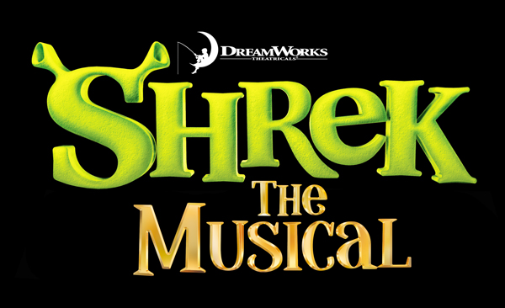
CHECKS payable to
T-shirt ORDER FORM

Troy Theatre Ensemble

or CASH preferred!

Shirt Color: Purple

Logo in FULL COLOR on FRONT

(on back of hoodie)

plus on sleeve in green ink:

Troy Theatre Ensemble 2016

Short sleeve shirts: $18

Long sleeve shirts: $21

Hooded zipper sweat shirts: $36

For XXL sizes, add $2.00

ORDER FORM

Short sleeve shirts: #_______ SIZE_______ TOTAL $ AMT.______

#_______ SIZE_______ TOTAL $ AMT.______

#_______ SIZE_______ TOTAL $ AMT.______

Long sleeve shirts: #_______ SIZE_______ TOTAL $ AMT.______

#_______ SIZE_______ TOTAL $ AMT.______

#_______ SIZE_______ TOTAL $ AMT.______

Hood Zip Sweat Sh: #_______ SIZE_______ TOTAL $ AMT.______

#_______ SIZE_______ TOTAL $ AMT.______

#_______ SIZE_______ TOTAL $ AMT.______

Tote Bag (one size) #____________________ TOTAL $ AMT._____

Sizes – Adult S, M, L, XL, XXL

TOTAL ORDER $ AMT. ______

NAME___________________________
Orders AND MONEY due by Wed., Feb. 17

